## Lab Questions: This is the Portion you will upload to Blackboard. Please DO NOT UPLOAD THE ENTIRE LAB. Just this page with the Result Set pasted in after each question.

1. As we did in Lab 2, open your SSMS object explorer and open your database folder. Now open the TABLES folder so we can see all of your tables. Capture a screen-shot of your explorer window that shows your server folder and your tables. Place a copy of the screen here:

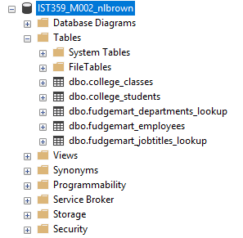

1. Create a Database Diagram of our FudgeMart schema. It should show your **three tables**, the **physical constraints** **and evidence of your FKs constraints**. Cut, copy, paste (or a screen shot) the diagram and place here. Oh dear. You don’t know how to do this but I bet you can figure it out if we know that SSMS has a tool that helps us create **DATABASE DIAGRAMS** and from there it is easy to **modify** what you see to include the **data types** and align the arrow so the FK constraint points right from the constrained column to the Primary Key of the Table it references. This is really, really, a great opportunity to search out on your own. If you can’t figure it out please list all of the keywords you used to search for the instructions and where you got stuck. Save your diagram and place a copy of it here. 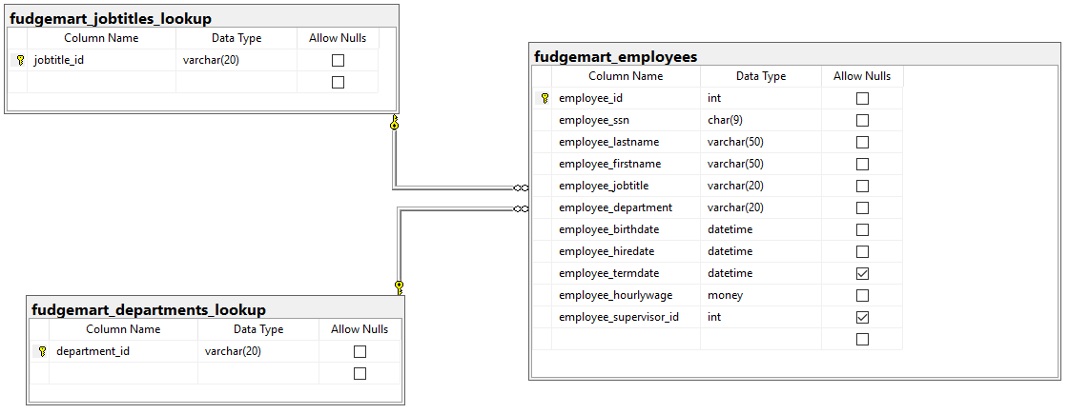
2. COPY/PASTE your entire script file here. Yes, it might be ugly, I can deal with that.

/* ***********************************************************************************************

IST 359 - Intro to DBMS

Lab 03 - Intro to SQL

Your Name:Nicholas Brown

NOTE: This lab will be done in 2 parts. You will want to use the same file for both parts.

When you are finished with both parts, you should be able to run this script in its entirety.

*********************************************************************************************** */

-- Part 1 Leave the following line of code here.

USE IST359_M002_nlbrown

IF EXISTS (SELECT * FROM INFORMATION_SCHEMA.TABLES WHERE TABLE_NAME = 'fudgemart_employees')

DROP TABLE fudgemart_employees

IF EXISTS (SELECT * FROM INFORMATION_SCHEMA.TABLES WHERE TABLE_NAME = 'fudgemart_jobtitles_lookup')

DROP TABLE fudgemart_jobtitles_lookup

IF EXISTS (SELECT * FROM INFORMATION_SCHEMA.TABLES WHERE TABLE_NAME = 'fudgemart_timesheets')

DROP TABLE fudgemart_timesheets

IF EXISTS (SELECT * FROM INFORMATION_SCHEMA.TABLES WHERE TABLE_NAME = 'fudgemart_departments_lookup')

DROP TABLE fudgemart_departments_lookup

GO

-- 2.a. Enter the code from the task in lab 03, part 1 here: DDL CREATE Fudgemart Departments

-- SELECT * FROM INFORMATION_SCHEMA.TABLES --

CREATE TABLE fudgemart_departments_lookup (

department_id varchar(20) NOT NULL,

CONSTRAINT PK_fudgemart_department_id

PRIMARY KEY (department_id)

)

GO

-- 2.b. Enter the code from the task in lab 03, part 1 here: Get Data in Fudgemart Department

INSERT INTO fudgemart_departments_lookup

(department_id) VALUES ('Customer Service')

INSERT INTO fudgemart_departments_lookup

(department_id) VALUES ('Electronics')

INSERT INTO fudgemart_departments_lookup

(department_id) VALUES ('Hardware')

INSERT INTO fudgemart_departments_lookup

(department_id) VALUES ('Sporting Goods')

SELECT * FROM fudgemart_departments_lookup

GO

-- 2.c. Enter the code from the task in lab 03, part 1 here: DDL for Jobtitles

CREATE TABLE fudgemart_jobtitles_lookup (

jobtitle_id varchar(20) not null

)

GO

-- 2.d. Enter the code from the task in lab 03, part 1 here: Define Jobtitles PK

ALTER TABLE fudgemart_jobtitles_lookup

ADD CONSTRAINT pk_jobtitle_id

PRIMARY KEY(jobtitle_id)

GO

-- 2.e. Enter the code from the task in lab 03, part 1 here: Get some data in Jobtitles

INSERT INTO fudgemart_jobtitles_lookup

(jobtitle_id) VALUES ('CEO')

INSERT INTO fudgemart_jobtitles_lookup

(jobtitle_id) VALUES ('Store Manager')

INSERT INTO fudgemart_jobtitles_lookup

(jobtitle_id) VALUES ('Department Manager')

INSERT INTO fudgemart_jobtitles_lookup

(jobtitle_id) VALUES ('Sales Associate')

SELECT * FROM fudgemart_jobtitles_lookup

GO

-- 2.f. Enter the code from the task in lab 03, part 1 here: DDL to create Employees w constraints

CREATE TABLE fudgemart_employees (

employee_id int not null,

employee_ssn char(9) not null,

employee_lastname varchar(50) not null,

employee_firstname varchar(50) not null,

employee_jobtitle varchar(20) not null,

employee_department varchar(20) not null,

employee_birthdate datetime not null,

employee_hiredate datetime DEFAULT getdate() not null,

employee_termdate datetime null,

employee_hourlywage money DEFAULT 8 not null,

employee_supervisor_id int null,

CONSTRAINT pk_employee_id PRIMARY KEY (employee_id),

CONSTRAINT ck_employee_minimum_wage CHECK

(employee_hourlywage>=8),

CONSTRAINT u_employee_ssn UNIQUE (employee_ssn),

CONSTRAINT ck_employee_birthdate CHECK

(datediff(yy,employee_birthdate,getdate())>15)

)

GO

-- 2.g. Enter the code from the task in lab 03, part 1 here: Define FK constraint in Employees

ALTER TABLE fudgemart_employees

ADD

CONSTRAINT fk_employee_department

FOREIGN KEY (employee_department)

REFERENCES fudgemart_departments_lookup(department_id),

CONSTRAINT fk_employee_jobtitle

FOREIGN KEY (employee_jobtitle)

REFERENCES fudgemart_jobtitles_lookup(jobtitle_id)

GO

-- 2.h. Enter the code from the task in lab 03, part 1 here: Load up 6 employees

INSERT INTO fudgemart_employees (

employee_id,

employee_ssn,

employee_lastname,

employee_firstname,

employee_jobtitle,

employee_department,

employee_birthdate,

employee_hiredate,

employee_hourlywage

) VALUES

(1,

'111220001',

'Photo',

'Arial',

'Sales Associate',

'Electronics',

'1/12/1982',

'4/16/2004',

12.70

),

(2,

'111220002',

'Ladd',

'Sal',

'Sales Associate',

'Electronics',

'11/30/1982',

'7/26/2005',

11.90

),

(3,

'111220003',

'Dawind',

'Dustin',

'Sales Associate',

'Hardware',

'9/3/1972',

'7/2/2004',

12.45

),

(4,

'111220004',

'Shores',

'Sandi',

'Sales Associate',

'Hardware',

'5/13/1990',

'6/26/2005',

10.50

),

(5,

'111220005',

'Gunnering',

'Isabelle',

'Department Manager',

'Electronics',

'2/22/1974',

'8/16/2005',

15.50

),

(6,

'111220006',

'Hvmeehom',

'Lee',

'Department Manager',

'Hardware',

'7/29/1973',

'1/26/2004',

14.85

)

GO

-- 2.i. Enter the code from the task in lab 03, part 1 here: DML: Lets see our employees

SELECT * from fudgemart_employees

GO

-- 2.j. Enter the code from the task in lab 03, part 1 here: DML: Who’s working in Electronics?

SELECT * from fudgemart_employees

WHERE employee_department = 'Electronics'

GO

-- 2.k. Enter the code from the task in lab 03, part 1 here: DML: And who are the managers?

SELECT * from fudgemart_employees

WHERE employee_department = 'Electronics'

AND employee_jobtitle <> 'Department Manager'

GO

-- 2.l. Enter the code from the task in lab 03, part 1 here DML: DML to update a row

UPDATE fudgemart_employees

SET employee_supervisor_id=5

WHERE employee_department = 'Electronics'

AND employee_jobtitle <> 'Department Manager'

GO

-- 2.m. Enter the code from the task in lab 03, part 1 here DML: DML to search and sort!

SELECT employee_firstname, employee_lastname, employee_hourlywage

FROM fudgemart_employees

WHERE employee_hourlywage > 12

ORDER BY employee_hourlywage

GO

-- Part 2

-- 3.a.

-- Write the SQL statement to build the fudgemart_timesheets

-- table columns only as outlined in section 1.b of the lab. Do not

-- create any constraints at this time

-- 3.b.

-- Modify the fudgemart_timesheets table to add the constraints

-- as outlined in section 1.b of the lab

GO

-- 3.c.

-- Write the code to add one week of timesheets for each employee

-- (6 statements total) for the week of 9/10/2007. Each employee

-- worked 45 hours

GO

-- 3.d.

-- Write the code to change the hours worked to 50 hours for the 2

-- managers HINT: you might have to look up their ID

GO

-- 3.e.

-- Write the single statement to change Lee Hvmeehom's name to Mike

-- Rofone. HINT: write your query such that you DO NOT USE THE ID

GO

-- 3.f.

-- Write the single statement to change the supervisor id of everyone

-- who works in the hardware department to the employee id of the

-- manager of that department. Hint: First figure out the ID of the manager of the Hardward Dept.

GO

-- 4.a.

-- Write the statement to show ALL of the rows in the table fudgemart_timesheets

GO

-- 4.b.

-- Execute the SQL from Section 4, question 2 of the lab here. In your Word document,

-- explain why it didn't work (in your own words. Don't copy/paste the error!)

GO

-- 4.c.

-- Execute the SQL from Section 4, question 3 of the lab here. In your Word document,

-- explain why it didn't work (in your own words. Don't copy/paste the error!)

GO